Image Classification of Handwritten Digits (MNIST) with a Convolutional Neural Network in PyTorch
Workshop – Unit 2: Convolutional Neural Networks (CNN) · Practical Work National Higher School of Mathematics (NHSM) · Supervisor: Dr. Amel Bouchemha Prepared by: Zakaria Karboua & Yakoub Kada · October 27, 2026

Abstract
This report presents the implementation and evaluation of a Convolutional Neural Network (CNN) that classifies handwritten digits from the MNIST dataset, built with PyTorch as the practical work of Workshop Unit 2. The network has two convolutional blocks followed by a two-layer classifier (225,034 trainable parameters) and was trained for five epochs with the Adam optimizer (learning rate 0.001, batch size 64). On the 10,000 held-out test images it reaches an accuracy of 98.96%, a macro-averaged precision of 0.9895, recall of 0.9896, F1-score of 0.9895 and a macro one-vs-rest ROC-AUC of 0.9999, with 104 misclassified images. Errors are concentrated on visually similar digit pairs (2 and 7, 9 and 4, 9 and 5), and many of the misclassified samples are ambiguous even for a human reader. The learning curves show a small generalization gap that appears after the second epoch. The report closes with limitations and concrete improvements.

1. Introduction
Convolutional Neural Networks are the reference architecture for image data. Instead of connecting every pixel to every neuron, they slide small learnable filters over the image, so that each unit looks at a local region (its receptive field) and the same filter is reused at every position. This weight sharing keeps the number of parameters low, preserves the spatial structure of the image and gives the network a degree of translation invariance. Stacking several convolution and pooling layers lets the network build a hierarchy of features, from edges and textures in the first layers to larger shapes in the deeper ones, before a fully connected classifier turns those features into class probabilities.
Handwritten digit recognition is the historical application of this idea: LeNet-5 (1998) was designed for exactly this task, and the MNIST dataset that grew out of that work is still the standard first benchmark for image classifiers. The goal of this practical work is to go through the complete pipeline on MNIST: prepare the data, design the network, write the training loop from scratch, and evaluate the result with a full set of classification metrics and an analysis of the errors.
The remainder of the report is organized as follows. Section 2 describes the dataset and the preprocessing. Section 3 presents the architecture. Section 4 details the training setup and the learning curves. Section 5 reports the test-set evaluation. Section 6 analyzes the errors, and Section 7 gives the conclusion, the limitations and possible improvements.

2. Dataset and Data Preparation
MNIST contains 70,000 grayscale images of handwritten digits from 0 to 9, each of size 28 × 28 pixels. The standard split was used: 60,000 images for training and 10,000 for testing. The ten classes are well balanced, with between 892 (digit 5) and 1,135 (digit 1) examples per class in the test set.
The preparation steps were the following:
- Conversion to tensors. Each image is converted to a PyTorch tensor of shape 1 × 28 × 28 and its pixel values are rescaled from the range 0–255 to 0–1.
- Normalization. The pixels are standardized with the usual MNIST statistics (mean 0.1307, standard deviation 0.3081), which centers the inputs and makes optimization faster and more stable.
- Batching. Training and test data are served by two DataLoader objects with a batch size of 64, which gives 938 iterations per training epoch. The training set is reshuffled at every epoch; the test set is not.
Figure 1 shows five random training images with their ground-truth labels. The digits are centered, white on a black background, and written in very different styles (compare the two 5s and the two 0s), which is the main source of difficulty in this task.
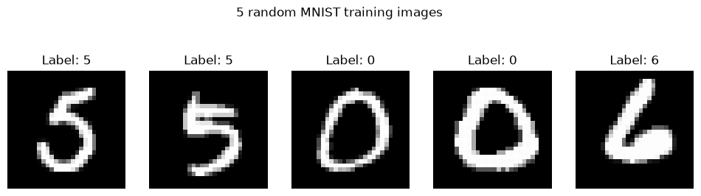
Figure 1. Five random MNIST training images with their ground-truth labels.

3. Model Architecture
The network, named CNNMNIST, follows the specification of the practical work: two convolution blocks that extract features, then a classification block. Both convolutions use 3 × 3 kernels with stride 1 and no padding, and both pooling layers are 2 × 2 max-pooling with stride 2. Table 1 gives the output shape and the number of parameters of every layer.
Stage | Layer | Output shape | Parameters
Input | Normalized grayscale image | 1 × 28 × 28 | 0
Block 1 | Conv2d (1 → 32, 3 × 3) + ReLU | 32 × 26 × 26 | 320
Block 1 | MaxPool2d (2 × 2, stride 2) | 32 × 13 × 13 | 0
Block 2 | Conv2d (32 → 64, 3 × 3) + ReLU | 64 × 11 × 11 | 18,496
Block 2 | MaxPool2d (2 × 2, stride 2) | 64 × 5 × 5 | 0
Classifier | Flatten | 1,600 | 0
Classifier | Linear (1,600 → 128) + ReLU | 128 | 204,928
Output | Linear (128 → 10) | 10 | 1,290
Total |  |  | 225,034
Table 1. Architecture of CNNMNIST.
The spatial sizes follow the formula output = (input − kernel + 2 × padding) / stride + 1. The image shrinks from 28 to 26 after the first convolution and to 13 after pooling, then to 11 and finally to 5 (the pooling layer rounds 5.5 down). The 64 feature maps of size 5 × 5 are flattened into a vector of 1,600 values.
Two observations are worth noting. First, the convolutional layers hold only about 8% of the parameters (18,816 out of 225,034); the first fully connected layer alone holds about 91%, because it connects each of the 1,600 features to 128 neurons. Second, the last layer outputs raw scores (logits) and no softmax is applied inside the model: the softmax is part of the cross-entropy loss during training and is applied explicitly when class probabilities are needed for the ROC analysis.

4. Training Setup and Learning Curves

4.1 Configuration
Item | Value
Loss function | Cross-entropy
Optimizer | Adam, learning rate 0.001
Batch size | 64 (938 iterations per epoch)
Number of epochs | 5
Hardware | CPU
Random seed | 42
Table 2. Training configuration.
The training loop was written explicitly. For every batch it resets the gradients, runs the forward pass, computes the loss, backpropagates the error and updates the weights. After each epoch the average loss and the accuracy were recorded on the training set and on the test set.

4.2 Results per epoch
Epoch | Train loss | Train accuracy | Test loss | Test accuracy
1 | 0.1362 | 95.87% | 0.0430 | 98.53%
2 | 0.0446 | 98.56% | 0.0309 | 98.99%
3 | 0.0296 | 99.08% | 0.0362 | 98.83%
4 | 0.0218 | 99.31% | 0.0302 | 99.16%
5 | 0.0176 | 99.42% | 0.0304 | 98.96%
Table 3. Loss and accuracy after each epoch.
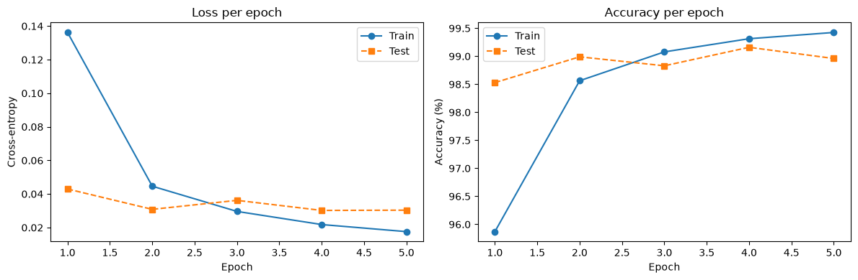
Figure 2. Cross-entropy loss (left) and accuracy (right) on the training and test sets.

4.3 Interpretation
The model learns very quickly: after a single epoch it already classifies 98.53% of the test images correctly. The training loss then keeps decreasing regularly, from 0.0446 at epoch 2 to 0.0176 at epoch 5. The test loss, on the other hand, stops improving after epoch 2 and stays around 0.030–0.036, and the test accuracy fluctuates between 98.8% and 99.2%. This is the typical beginning of overfitting: the network keeps fitting the training set better without generalizing better. At epoch 5 the gap between training accuracy (99.42%) and test accuracy (98.96%) is small, about 0.46 percentage points, so the overfitting is mild for this training length.
Two details of the curves should be read with care. In epoch 1 the training accuracy (95.87%) is lower than the test accuracy (98.53%) because the training figure is averaged over the whole epoch, while the network is still improving, whereas the test figure is measured once with the weights obtained at the end of the epoch. Also, the best test accuracy appears at epoch 4 (99.16%), but the final model of epoch 5 (98.96%) is the one evaluated below; the difference of 0.2 point corresponds to about 20 images and is within the normal variation of a single run.

5. Evaluation on the Test Set

5.1 Global metrics
The trained model (weights after epoch 5) was evaluated once on the 10,000 test images. Let TP, TN, FP and FN be the numbers of true positives, true negatives, false positives and false negatives for a given class. The metrics are defined as follows.
- Accuracy = (TP + TN) / (TP + TN + FP + FN): the proportion of images classified correctly.
- Precision = TP / (TP + FP): among the images predicted as a class, the proportion that really belong to it.
- Recall = TP / (TP + FN): among the images of a class, the proportion that the model finds.
- F1-score = 2 × Precision × Recall / (Precision + Recall): the harmonic mean of precision and recall.
- ROC-AUC: the area under the ROC curve, which does not depend on a decision threshold. For ten classes it is computed one-vs-rest on the softmax probabilities.
Precision, recall and F1 are macro-averaged (each class has the same weight). Because MNIST is nearly balanced, the macro and weighted averages are practically identical.
Metric | Value
Accuracy | 0.9896 (98.96%)
Precision (macro) | 0.9895
Recall (macro) | 0.9896
F1-score (macro) | 0.9895
ROC-AUC (macro, one-vs-rest) | 0.9999
Misclassified images | 104 out of 10,000
Table 4. Test-set performance.
With 10,000 test images, the standard error of the accuracy is about 0.10 percentage points, so a 95% confidence interval for the true accuracy is roughly 98.8% to 99.2%. The four threshold-based metrics are almost equal, which shows that the model is not trading precision for recall: its errors are spread rather evenly across the classes.

5.2 Per-class results
Digit | Precision | Recall | F1-score | Support | ROC-AUC
0 | 0.9829 | 0.9980 | 0.9904 | 980 | 1.0000
1 | 0.9965 | 0.9938 | 0.9951 | 1,135 | 1.0000
2 | 0.9941 | 0.9797 | 0.9868 | 1,032 | 1.0000
3 | 0.9921 | 0.9921 | 0.9921 | 1,010 | 1.0000
4 | 0.9878 | 0.9929 | 0.9904 | 982 | 1.0000
5 | 0.9888 | 0.9877 | 0.9882 | 892 | 0.9999
6 | 0.9958 | 0.9906 | 0.9932 | 958 | 0.9999
7 | 0.9817 | 0.9903 | 0.9860 | 1,028 | 0.9999
8 | 0.9877 | 0.9897 | 0.9887 | 974 | 0.9999
9 | 0.9880 | 0.9812 | 0.9846 | 1,009 | 0.9999
Macro average | 0.9895 | 0.9896 | 0.9895 | 10,000 | 0.9999
Table 5. Precision, recall, F1-score and ROC-AUC for each digit.
All ten classes have an F1-score above 0.984. The easiest digits are 1 (F1 = 0.9951), 6 (0.9932) and 3 (0.9921). The hardest are 9 (0.9846), 7 (0.9860) and 2 (0.9868). The lowest recalls belong to digit 2 (97.97%, 21 of 1,032 images missed) and digit 9 (98.12%, 19 of 1,009 missed), while the lowest precisions belong to digits 7 (98.17%) and 0 (98.29%), which means that other digits are wrongly assigned to them.

5.3 Confusion matrix
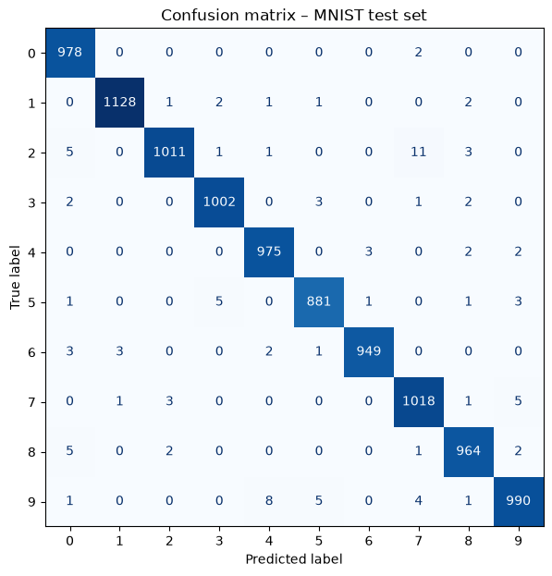
Figure 3. Confusion matrix on the 10,000 test images (rows: true digit, columns: predicted digit).
The matrix is strongly diagonal: between 881 (digit 5) and 1,128 (digit 1) images are correctly classified in each row. The 104 errors are spread over many cells, mostly with one to five images each, and only a few cells are clearly larger. Digit 2 is the class with the most errors (21), followed by digit 9 (19) and digit 5 (11).

5.4 ROC curves
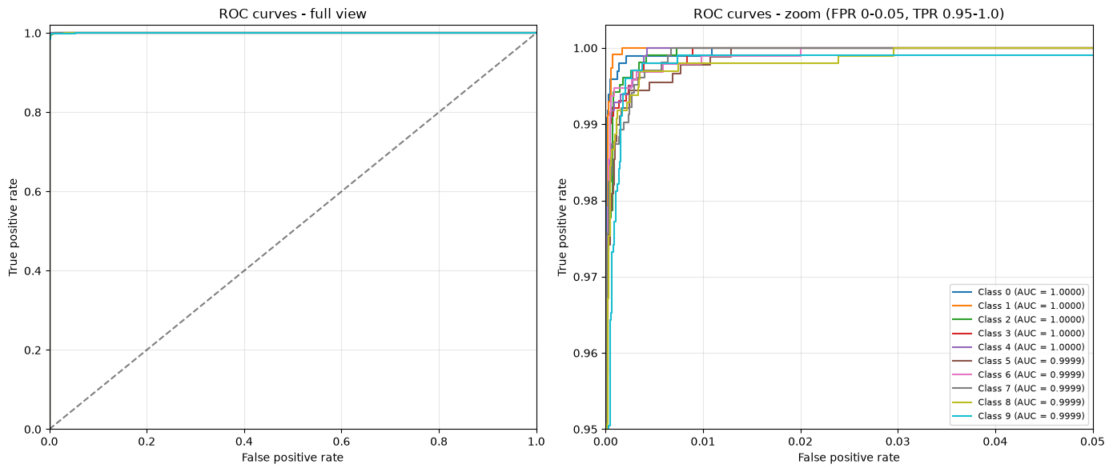
Figure 4. One-vs-rest ROC curves for the ten digits: full view (left) and zoom on the top-left corner (right).
At full scale the ten curves cannot be told apart: they follow the left and top borders of the plot, far from the diagonal that represents a random classifier. This is why the zoomed panel was added. In it, all curves reach a true positive rate above 0.99 for a false positive rate below about 0.01. The curve of digit 1 is the first to reach 1.0, while digits 8 and 9 need a larger false positive rate to get there, which is consistent with their slightly lower AUC (0.9999 against 1.0000 for digits 0 to 4). In practice, the ranking produced by the softmax probabilities almost perfectly separates each digit from the rest, and the remaining errors come from images on which the model is confidently wrong rather than from a poorly chosen decision threshold.

6. Error Analysis
The model misclassifies 104 of the 10,000 test images (1.04%). Table 6 lists the most frequent confusions reported by the notebook; several other pairs, such as 8 predicted as 0 and 2 predicted as 0, also occur five times.
True digit | Predicted digit | Number of images
2 | 7 | 11
9 | 4 | 8
9 | 5 | 5
7 | 9 | 5
5 | 3 | 5
Table 6. Most frequent confusions.
These pairs are the ones whose shapes overlap most in handwriting: a 2 written with a short base can resemble a 7, a 9 with an open loop resembles a 4, and a 7 with a curved stem resembles a 9. A 5 and a 3 share the same curved lower part. This explains why digit 7 has the lowest precision (it absorbs the 11 twos) and why digits 2 and 9 have the lowest recalls.
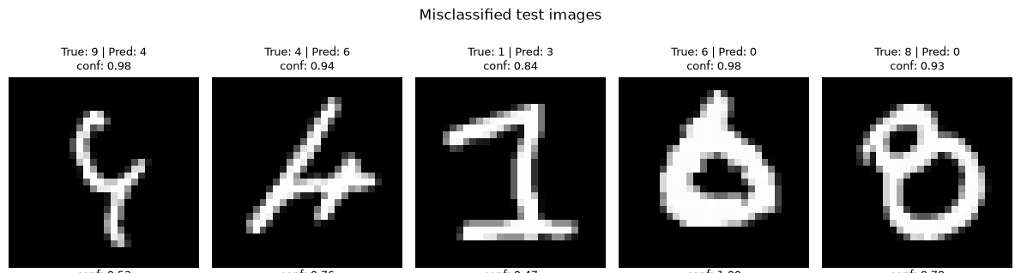
Figure 5. Five misclassified test images with the true label, the predicted label and the confidence of the prediction.
The examples in Figure 5 lead to three remarks. First, most of these digits are genuinely ambiguous: the "9" drawn as a Y-shaped stroke, the "4" made of a few scribbled strokes and the "6" with a closed loop and almost no stem would be hard to read even for a person, and a few MNIST test labels are debatable. Second, the model is often very confident when it is wrong, with confidences between 0.84 and 0.98 on these five images, so the softmax output should not be interpreted as a calibrated probability. Third, the errors are due to unusual writing styles and not to a systematic weakness on one digit, which suggests that further gains would come from better regularization and data augmentation rather than from a larger model.

7. Conclusion

7.1 Summary
A compact CNN with two convolution blocks and 225,034 parameters, trained for only five epochs on a CPU, classifies 98.96% of the MNIST test images correctly, with a macro F1-score of 0.9895 and a macro ROC-AUC of 0.9999. The practical work met its objectives: the data pipeline, the convolution and pooling layers and the explicit training loop were implemented in PyTorch, and the classifier was evaluated with accuracy, precision, recall, F1-score, ROC-AUC and the confusion matrix. The model learns fast, generalizes well, and makes errors mainly on ambiguous digits and on visually close pairs (2/7, 9/4, 9/5, 7/9, 5/3). The learning curves show only the beginning of overfitting, with a gap of 0.46 point between training and test accuracy.

7.2 Limitations
- Single run. Only one training run with one random seed was made, so the small differences between epochs (for example 99.16% at epoch 4 against 98.96% at epoch 5) cannot be interpreted as real effects.
- No validation set. The test set was used to monitor the curves after each epoch. No model selection or tuning was done on it (the final epoch is reported), but any future tuning of hyperparameters should use a separate validation split.
- No regularization. The network has no dropout, batch normalization, weight decay or data augmentation, and the convolutions use no padding, so information at the borders of the image is used less.
- Short training. Five epochs were used as required by the assignment; the test loss had already stopped improving after epoch 2.
- Easy benchmark. MNIST is a simple dataset (small, centered, grayscale digits), and the results do not transfer directly to natural or more complex images.

7.3 Possible improvements
- Add dropout after the first fully connected layer and batch normalization after the convolutions to reduce the gap between training and test performance.
- Use data augmentation (small rotations, shifts and scaling) to make the model more robust to writing styles such as those of Figure 5.
- Use padding = 1 to keep the spatial size and the border information.
- Hold out a validation set (for example 5,000 of the 60,000 training images) and use early stopping or a learning-rate scheduler, selecting the epoch on the validation data.
- Average several models (ensemble) and apply temperature scaling if well-calibrated probabilities are needed.
Well-tuned CNNs are known to exceed 99.5% accuracy on MNIST, so the 0.5 to 0.6 point margin between this baseline and that level is the realistic room for improvement.

Appendix: Reproducibility
Component | Version
Python | 3.14.8
PyTorch | 2.14.1 (CPU build)
torchvision | 0.29.1
NumPy | 2.5.3
Matplotlib | 3.11.2
scikit-learn | 1.9.1
Table 7. Software environment used for the experiments.
The code is provided in the notebook Unit2_CNN_MNIST_Practical.ipynb, which runs the four steps of the assignment in order (data preparation, model, training, evaluation). The random seed is fixed to 42 for Python, NumPy and PyTorch.

